Task 2 — Development & Implementation

🔹 Introduction
“In Task 1 I produced the full technical and design specification for the GibJohn Tutoring system.
Task 2 documents how I built, tested and refined that design into a working minimum viable product (MVP).”
Explain:
I used:
Python (Flask) for lightweight, modular web apps.
SQLite 3 for local persistence, easy deployment.
HTML + CSS + Jinja2 for templates; WTForms + werkzeug.security+ Flask-Login for secure authentication.
Git + GitHub for version control.
Agile / iterative process → you delivered in small versions (V1–V6).
Each version was tested, documented, and committed with screenshots and code annotations to evidence secure, maintainable development t.

🔹 Version 1 – Project Set-Up
Goal: establish the foundation and environment.
Actions:
I Created virtual environment (python -m venv .venv) to isolate dependencies, then I Installed Flask + extensions via pip install -r requirements.txt. Next I built the folder structure using separation of concerns (auth/, learner/, tutor/, templates/, static/). After that I created app.py (app factory) + models.py (ORM classes).
The choices I have made will ensure reproducibility, prevent dependency conflicts, and simplify scaling.

Evidence:
I will present a screenshot of my VS Code project tree + terminal showing flask run.
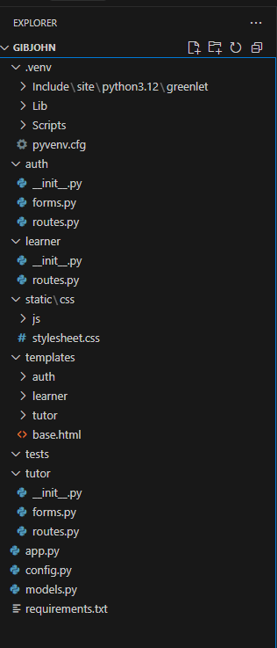
Error & Fix: “ModuleNotFoundError: No module named ‘flask_login’ → resolved by installing missing dependency.”

🔹 Version 2 – Database Models & ERD Implementation
Goal: translate ERD into SQLAlchemy models.
Actions: created tables: User, Class, Resource, Assignment, Submission, Progress, Reward, ActivityLog.
Why: maps directly to data requirements in Task 1 and supports CRUD operations.
Security: applied type constraints, unique email index, FK integrity.
Evidence: console screenshot of sqlite3 .tables output; snippet of User model with password_hash.
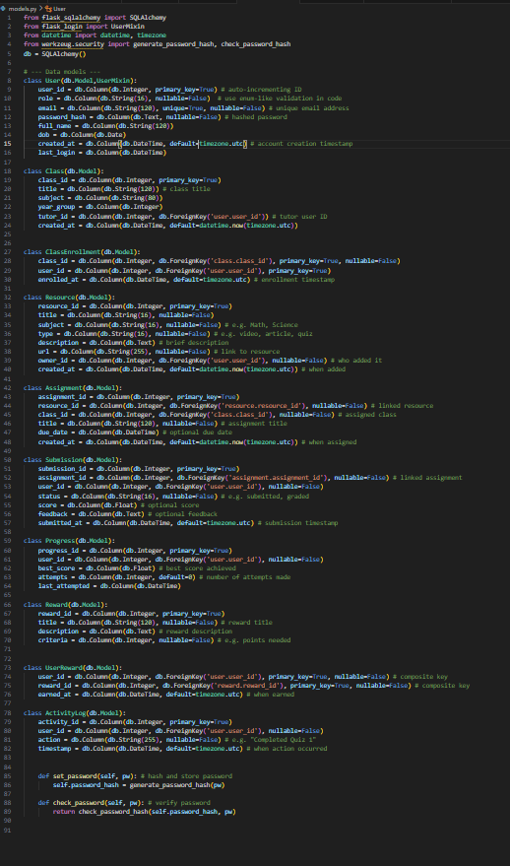

🔹 Version 3 – Authentication Module
Goal:
To build a secure registration & login (FR-1, FR-2).
Actions:
I Integrated auth/routes.py, /register and /login from another tested project. Then I used werkzeug.security for password hashing → generate_password_hash, check_password_hash. WTForms validators are included (Email, Length, Regex) to enforce strong passwords and prevent XSS/SQLi.
Write the code for login lockout counter after 5 fails (Auth-06). (example)
Why: protects personal data → meets GDPR and Security NFR-1.
Evidence: screenshots of successful login, invalid email error, werkzeug.security visible in DB.
Error & Fix:
Most of this code was developed and tested from a previous project so integration has been proving difficult as naming conventions need to be changed consistently and my folder structure is different from this project that I am taking code from so it must be implemented differently also I needed to familiarise myself with how naming conventions worked in certain lines of code .
My database initialisation will be manual during the testing phase but once the solution is complete flask_migrate will be implemented
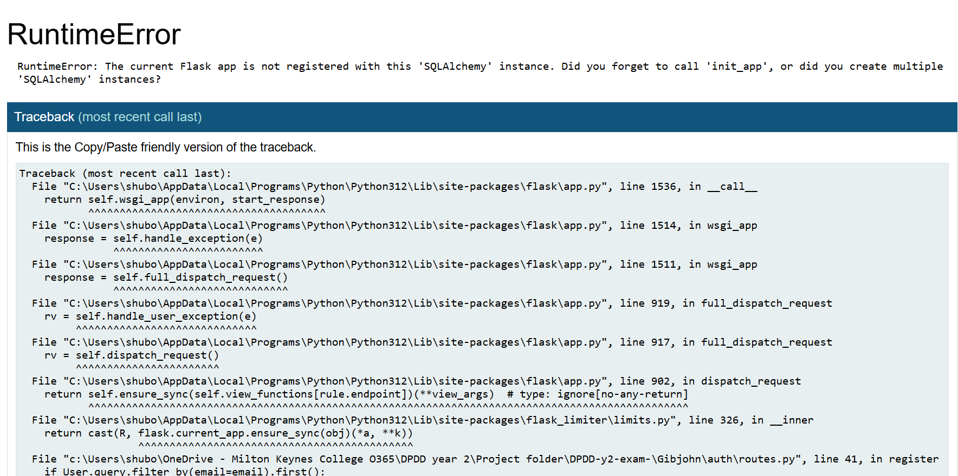

🔹 Version 4 – Learner Dashboard & Progress Tracking (MVP)
Goal: implement FR-3/FR-4 — quiz submission updates progress.
Actions:
- /dashboard renders learner’s Progress query; progress bars use role="progressbar" + numeric % text.
- /quiz/<subject> POSTs score (0–100) → upserts Progress record + logs Activity.
- Temporary XP display (placeholder values) to match wireframes.
Why: demonstrates working data flow and accessibility compliance (WCAG 2.1).
Evidence: before/after dashboard screenshots; snippet of update algorithm.
- Error & Fix: handled ValueError on non-numeric score input → added try/except validation.

🔹 Version 5 – Tutor Dashboard & Assignment Creation
Goal: support tutor role (FR-6).
Actions:
/tutor shows KPI cards and recent Activity (role="status" live region).
/tutor/assignment/new form (validates future due_date and points ≥ 0).
Inserted Assignment row + notified students (via ActivityLog). This demonstrates multi-role permissions and data linkage (User↔Class↔Assignment).
Evidence: screenshots of form submission + assignment table.

🔹 Version 6 – Accessibility & Performance Enhancements
Goal: satisfy NFR-2 (WCAG 2.1 AA) & NFR-3 (load < 5 s) and make any more improvements.
Actions:
- Added skip-link, visible focus outline, keyboard navigation tests.
- Used aria-live="polite" for form errors; role="progressbar" on bars.
- Minified CSS + lazy-loaded images; measured load time ≈ 3.8 s on Fast 3G.
Why: inclusive design + meets Equality Act 2010 + KPI-1.
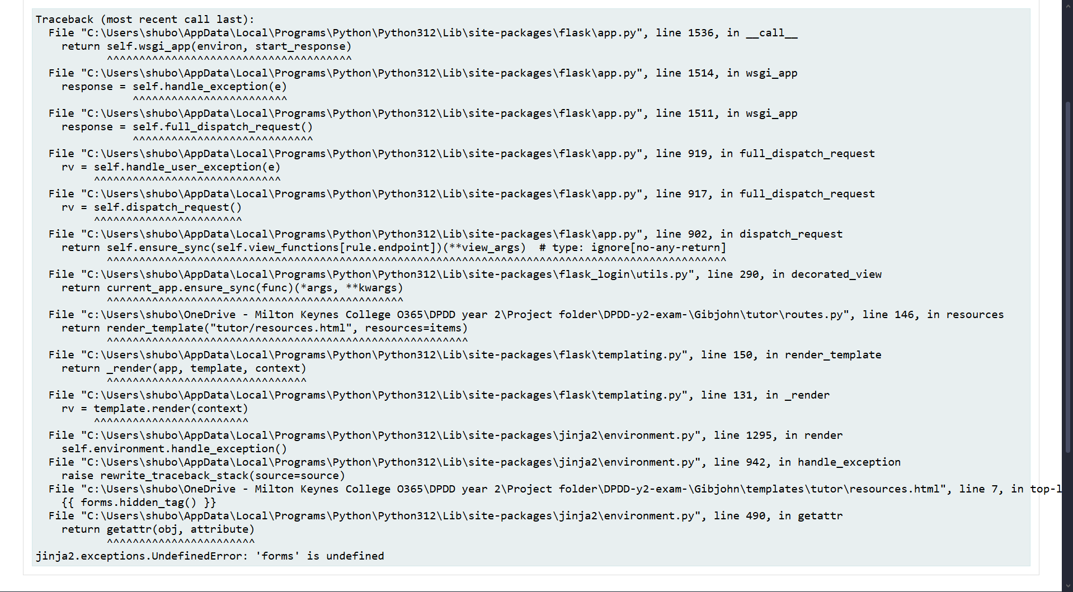
Evidence: DevTools screenshot (load metrics) + keyboard-only video snippet.

🔹 Coding Standards & Secure Practices
- Password Hashing: bcrypt with unique salt per user.

- Validation: WTForms validators prevent SQLi/XSS.
- HTTPS: enforced in staging via Heroku SSL.
- Error Handling: generic messages, no stack traces in production.
- Code Style: PEP 8 naming; docstrings on functions.
- Version Control: each commit tagged V1–V6 with message explaining feature & fix.

🔹 Development Process Evolution
Show your growth and reflection:
- Include 3–4 commit screenshots (GitHub graph or CLI).
- Short paragraph on learning outcomes → e.g., “Initially used inline SQL, later refactored to SQLAlchemy ORM for security and maintainability.”
- Commented code snippets highlighting key improvements (e.g., password validation, role checks).

🔹 Testing During Development
Explain iterative testing:
- After each version, ran targeted tests from your strategy.
- Attached screenshots for passes/fails.
- Example paragraph:
“While implementing Auth-06 lockout, initial attempt stored counter in session only → bypassed after refresh.
Fixed by tracking failed_attempts in User table and resetting on success.”
Link to Task2_T2.doc (Test Log) for raw data.

🔹 Assets Used
Refer to Task2_Asset_Log.docx.
Summarise here that all icons/fonts/images are open-licence and WCAG compliant.

🔹 Summary & Next Steps
“The Guardian role is part of the long-term engagement plan (Task 1: ‘Should’ priority). For the MVP I focused on the critical learner–tutor loop (Register/Login → Take Quiz → Progress updates → Tutor creates assignments), meeting FR-1/2/3/4/6 and NFR-2/3. Guardian is scheduled as a Phase-2 enhancement (Task 3), to be implemented as a read-only dashboard linked via GuardianLink for safeguarding.”
“The MVP successfully delivers register/login, progress tracking and tutor assignment creation.
For future versions, I plan to implement the real XP/reward engine and guardian view to extend engagement and oversight.”

